# File permissions in Linux

## Project description

In this project we are exploring the use of bash commands to modify permissions in files & directories

## Check file and directory details

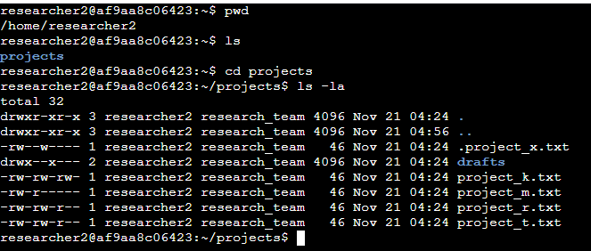

## Describe the permissions string

From the screenshot above we can see that we are starting this project but using multiple linux commands. The first command is to check which directory we are in with pwd, next we use ls to show all files within this location, then using the cd projects command we put ourselves into that directory. Once in the directory we use ls -la which lists all of the permissions of the files within this directory including hidden files (as shown using the a). The character string drwxr-xr-x is displayed in the first 2 lines, what this all means is that in the directory (d) the user group (characters 2,3,4) all have the read (as shown by r), write (w) and execute (x) permissions for the home directory. The remaining characters in the 10 character string allows the ‘other’ group to execute and read but not write within the directory. In the more specific files including the hidden file (as indicated with the . at the start) many are allowed to read and write but not execute.

## Change file permissions



As we see from the previous screenshot we noticed that the ‘other’ group had write permissions within project_k.txt, this is not allowed by the company so with the command we used above we simply changed the permissions to not allow the ‘other’ group to write on the file but only read.

## Change file permissions on a hidden file



From using the commands previously it has been determined that in the hidden archived file .project_x.txt the user & group should be allowed to read the file but not write, as shown in the screenshot we have changed the permissions to allow only reading and removed the permission of writing

## Change directory permissions



It has been determined that researcher2 should be the only person able to access the drafts directory, with the screenshot above we changed the permissions of removing all groups from being able to execute the command of viewing drafts.

## Summary

Within this project we were exploring some of the uses that can be done with bash. Many of the commands that we executed today were focused on user permissions and changing said permissions, not only did we modify certain files but we also changed directories permissions. This small project is just a stepping stone into becoming more confident with linux commands and enhancing our toolset to becoming a confident user.